ARTIFICIAL INTELLIGENCE

**211321104009: S.S.Sowmya**

Phase 2 : Innovation

**Chatbot in Python**:

According to this phase we are going to do about what are the innovations that we are required to innovate python in a new type and use the Chatbot in an innovative way.

Here now the Chatbot is instructed to done a answer which was asked by the user but the chatbot are much easier to design an algorithm to install the chatbot program.In this phase we innovate the Chatbot which we are going to integrate it with a Website or an Application.By integrate it with such a Website or an Application we are making that the chatbot to work as an external software model. The Chatbot which we are programmed as in Python we could run it in Python but by integrating it to any other software such as Website or Application we can use it anywhere from the app or the website Url. Here we all are know about **CHATGPT** it is an Chatbot but we can access the Chatbot in either external application or website. The Chatbots are mostly used in many fields in various roles and areas.

The world have already witnessed many innovative chatbots in the modern days ,Some Chatbots are

* COVIDAsha bot
* Endurance bot
* Casper bot
* UNICEF bot

Here from the datasets that are already given the Python program to Develop or Run a Python Chatbot ,we were added or attended a small set of datasets we are created and here the Python Program and the Sample output in the python Software to be added.

After the Submission the Chatbot Python program to be integrated to a Website or Application then the Final Submission to be Submitted with model that we are created.

SAMPLE PYTHON PROGRAM OF CHATBOT:

import random

# Define responses

responses = {

"hello": ["Hi there!", "Hello!", "Hey!"],

"how are you": ["I'm just a bot, but I'm doing fine.", "I don't have feelings, but I'm here to help!"],

"bye": ["Goodbye!", "See you later!", "Bye bye!"],

"default": ["I'm not sure how to respond to that.", "Could you please rephrase that?", "I'm still learning!"]

}

# Function to get a response

def get_response(message):

message = message.lower()

if message in responses:

return random.choice(responses[message])

else:

return random.choice(responses["default"])

# Main loop

print("Chatbot: Hi there! How can I assist you? (type 'bye' to exit)")

while True:

user_input = input("You: ")

if user_input.lower() == "bye":

print("Chatbot: Goodbye!")

break

response = get_response(user_input)

print("Chatbot:", response)

SAMPLE OUTPUT FOR THE PYTHON PROGRAM:

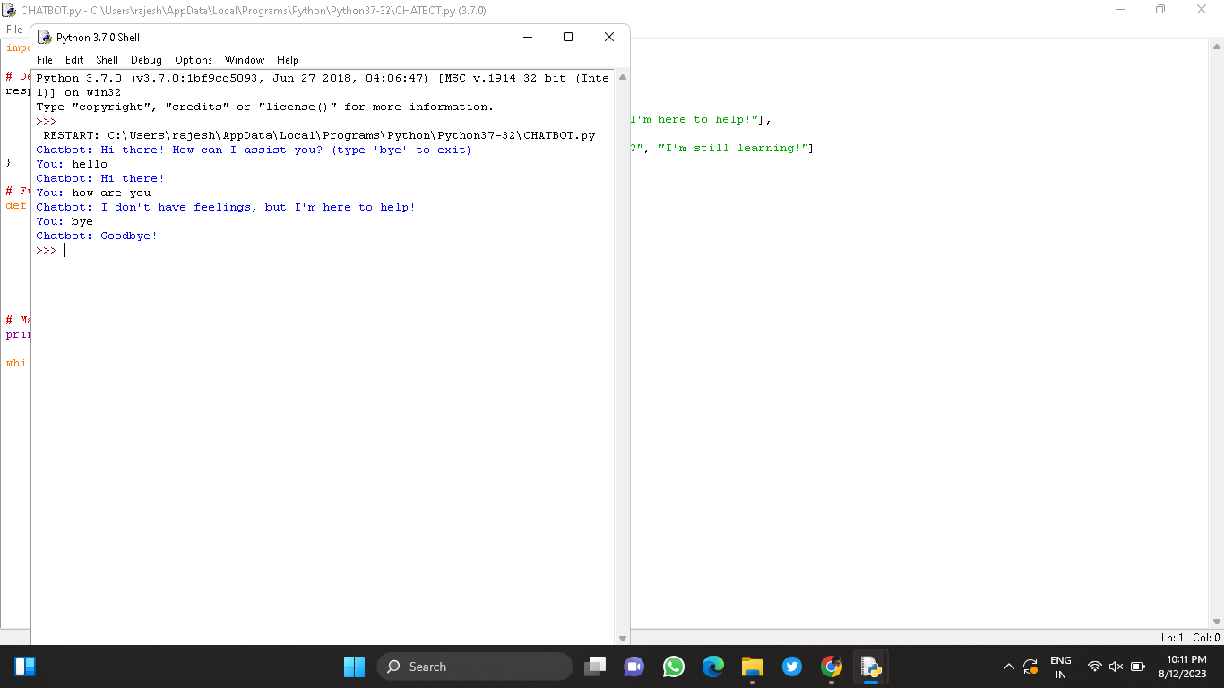

CONCLUSION:

The Sample program for the Chatbot and the Sample Output for the Chatbot is added .The Chatbot is developed furtherly innovated in more steps and ways that are been developed with the Questions and Answers.

THANK YOU